|  |
| --- |
| CS 440 |
| Programming Languages and Translators |
|  |
| MCL: Lex analyzer report |
| 02/12/2017 |

|  |
| --- |
| Yuyang Luo  [yluo41@hawk.iit.edu](mailto:yluo41@hawk.iit.edu)  Cai Chen  zdthm007@gmail.com |

# Tokens in MCL language

Basic element:

Digit: $[0-9]$

ID: $\left[a-zA-Z\right]{\left[a-zA-Z0-9\right]}^{*}$

Build-in functions:

_row_|_colum_|_printm_|_{ID}_

Basic Data;

integer: {Digit}+

real number: {DIGIT}+"."{DIGIT}*

Keyword:

Data Type: int|real|matrix

Condition: if|else|return|def|for|Null

Operators:

Basic operators: "+"|"-"|"*"|"/"|"="|"^"

Matrix operators: ".*"|"./"

Boolean operators: "=="|"!="|"&&"|"||"|"<"|">"|"<="|">="

Punctuations:

"("|")"|"{"|"}"|"["|"]"|":"|","|";"

Comments:

Same style like c and c++ comments, everything between “/*” and “*/” or “//” and “\n” are comments

\/\*([^*\"]*|\".*\"|\*+[^/]|\")*\*\/|\/\/[^\n]*

# Finite machine

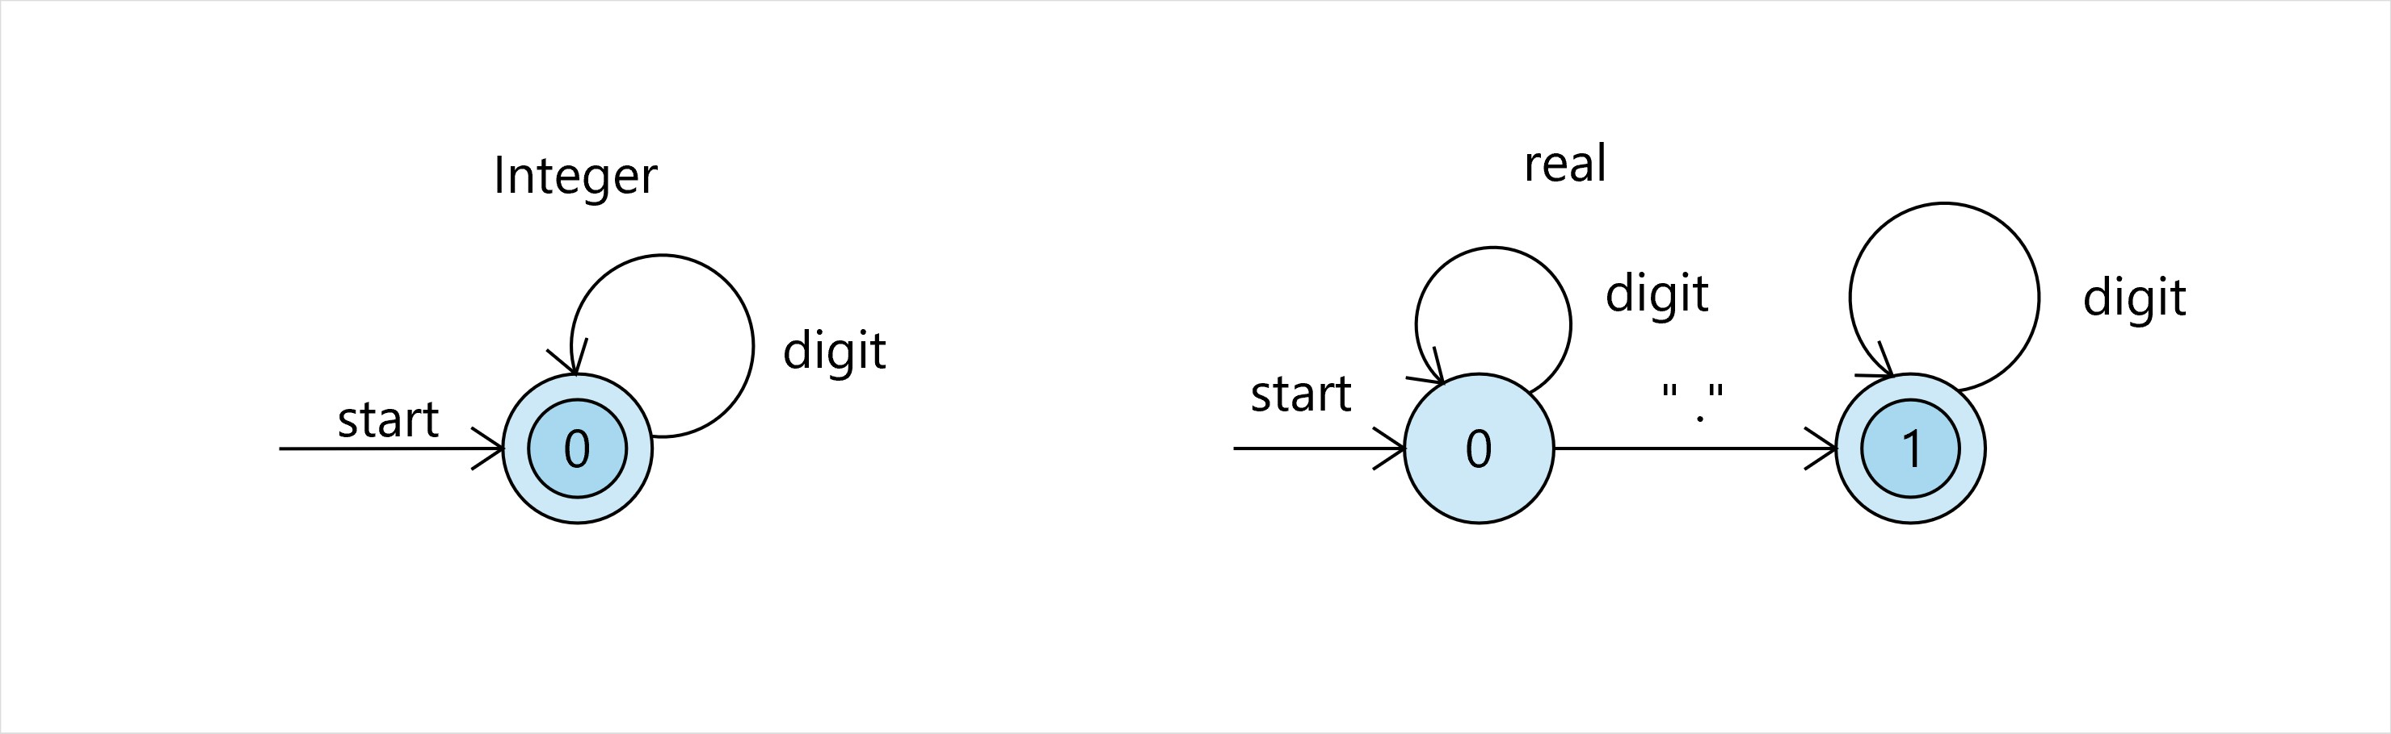

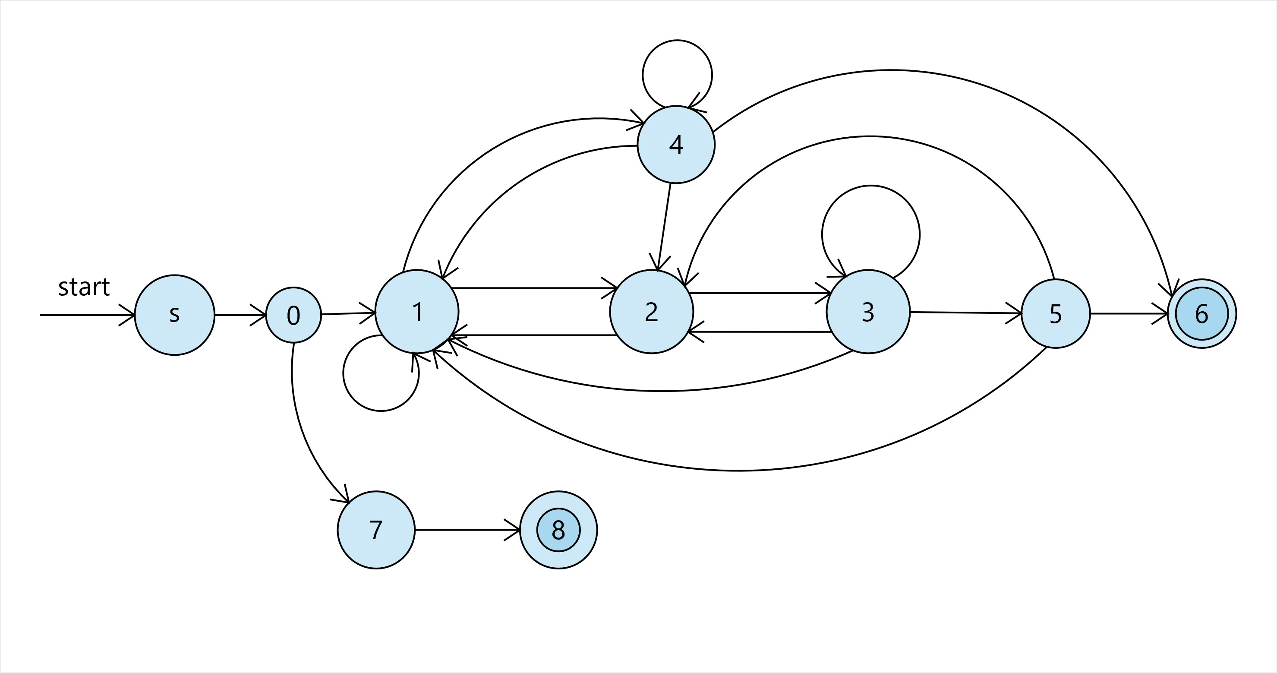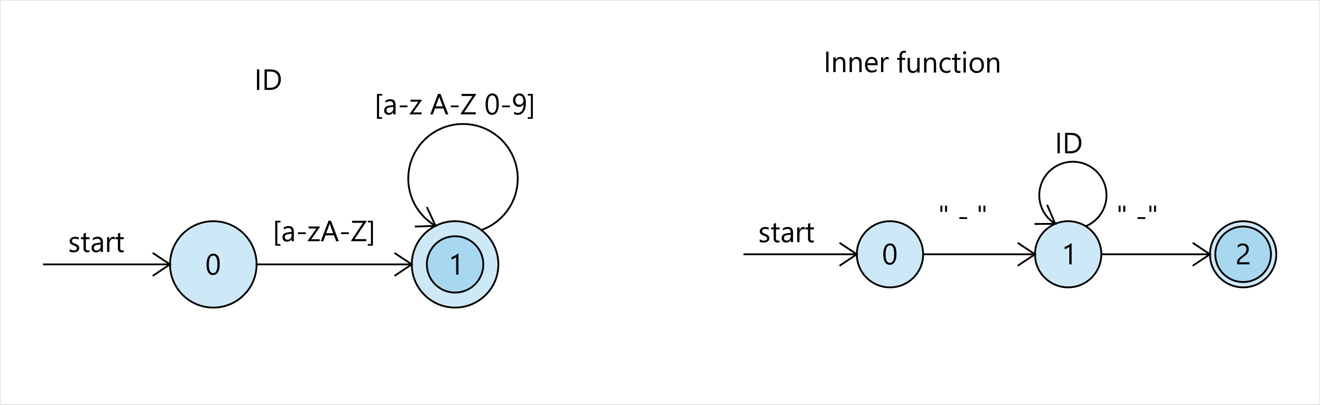

[^”]

\*

[^\n]*

\/

[^\*”]*

”

”

[^\/\*”]

\*

$

\/

\*

\/

\*

”

”

”

[^\/\*”]

\*

\/